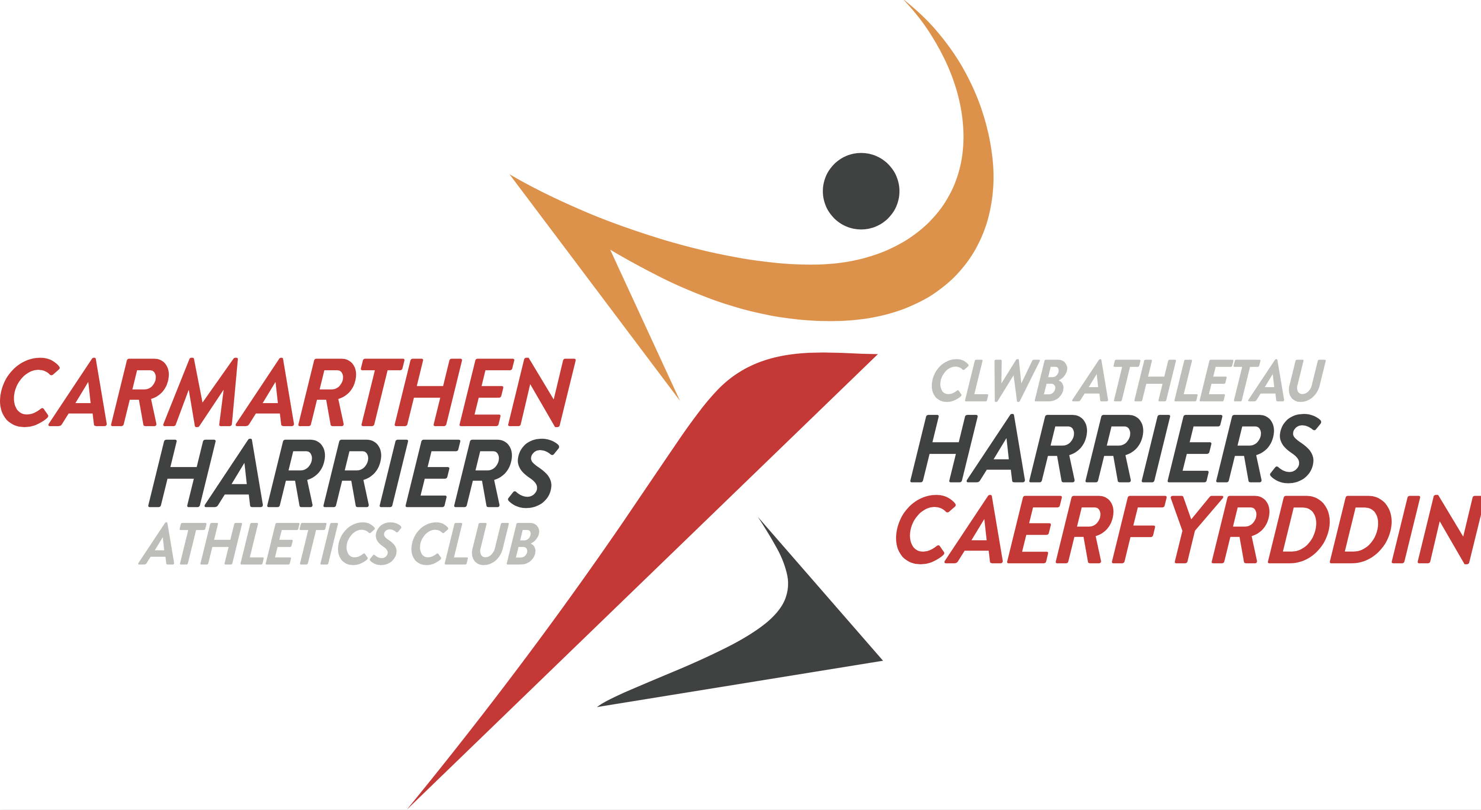

Annwyl Aelod/ Dear Member,

Fe'ch gwahoddir i Ginio Blynyddol Clwb Athletau Harriers Caerfyrddin a'r Cylch.

You are invited to Carmarthen and District Harriers Annual Dinner.

12.10.19
7.00pm
Ivy Bush Royal Hotel
Carmarthen

RSVP

-----------------------------------------------------------------------------------------------------------
I would like to reserve spaces for the following people at the Annual Dinner 12.10.19

PAYMENT:
I enclose a total payment of £ ___________________ (Children under 16 £16 / Adults £18)

CONTACT DETAILS (mobile or email) :

ANY DIETARY REQUIREMENTS:

Please note if there is anyone you would particularly like to share a table with

Forms and payment to be returned by 30.9.19 to: Secretary, 10 Penllwyn Park, Carmarthen SA31 3BU or returned to a committee member on training night. Any questions please email secretary.carmarthenharriers@hotmail.com

